**INVOICE PROCESSING USING RPA**

The project “Invoice Processing Using RPA” is about how to automate the manual process of invoice assessment and restoring which includes certain confinement to validate and approve the invoice request. Computer software or a “robot” to capture and interpret existing applications for processing a transaction, manipulating data, triggering responses and communicating with other digital systems. The RPA (**Robotic Process Automation**)robot, does not matter which application is used to process the invoice data. This can be any kind of accounting or ERP system. When the invoice data is inserted into the application, a transaction number is generated by the system.

**PROBLEM DEFINITION**

Invoice processing using RPA has performed with a help of

Ui-Path. Collect a invoice template from different invoice format. Those invoices are extract to a specific data from different template of PDF file. Read those unread mails by using required activities. We use IMAP mail messages activity for receive those mails. Depend on those activities we automate the mail. Then convert those PDF file to Excel sheet format.The existing claim approval system needs a human to assess and approve the requests, which is liable to mistakes and lot of time consumption and man power. Our proposed system reduces them by automating the whole complete process using a software robot which will be much faster than the existing system, also reduces the time and man power consumption.

**TOOLS USEDUiPath :** UiPath is a software structure to improve automation applications. It runs on Microsoft Windows and it was settled on the top of Net framework and Windows workflow base tools. UiPath scores best in technology category. There are three main components in UiPath. UiPath Studio is a tool that enables you to design automation processes in a visual manner, through diagrams. UiPath Robot executes the processes built in Studio, as a human would. UiPath Orchestrator is a web application that enables you to deploy, schedule, monitor and manage Robots and processes.

**TECHNOLOGY TO BE USED:** UiPath tool

**MODULE SPLIT UP** Module 1

Create a invoice template.

Attach a template into email.

Module 2

Read a unread message using Ui-Path.

Split it into a folder.

Module 3

Create a flow for all invoice.

Convert those invoice from PDF to Excel sheet.

And send a mail notification to the required client.

**INPUT:**

The input will be obtained from the client through excel or pdf with the following details:

* Invoice number
* Due date

**Input Business File**

* The input business file module is used to get the Invoice number as input which is given to the email .
* The client will send the details about the Invoice numbers of various company which are to be processed.
* The input business file can be obtained in any of the below two formats:

1. Excel
2. PDF

* Based on the subject and date, the email will be checked and the attachment will be downloaded automatically. (Only the unread mail will be checked and it will be processed).
* In case, if the client sends the attachment as an PDF then it will converted into PDF document and then the further steps will be processed.
* In case, if the client sends the attachment as excel then it will be processed directly.

**Overview of the Project**

The invoice system is used to overcome the entire problem which they are facing currently, and making complete automation of billing and invoice system. The first step of the process consists out of the selection of the right PDF invoice in a dedicated folder. For the RPA bot, it does not matter which application is used to process the invoice data. This can be any kind of accounting. And next step reading the invoice form the folder one by one and extracting the key information from the invoice data. After success fully registering the each invoice, the software robots are then able to send posting notifications in the form of emails to responsible employees. Other background activities, during this whole process the software robots are also running background activities such as monitoring the dedicated invoice folder or its email address, performing basic checks to see is company's database is open and verifying by the vendor information. And the invoice matches what is already in the database.

**Snapshots:**

**INPUT**

1. Check Internet Status

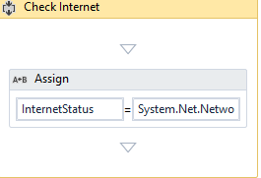

1. Get Password



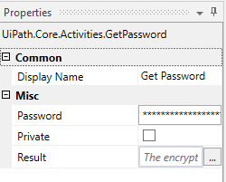

3.Receive Mail 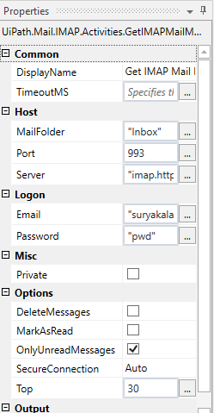

`

4.Attachment

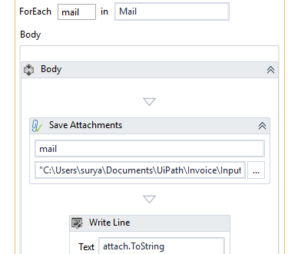

5.Get Files

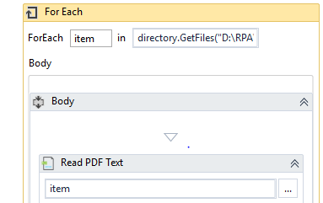

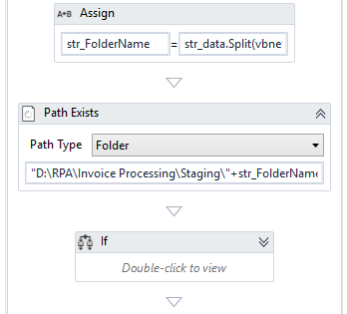

**OUTPUT:**

1. Attached PDF

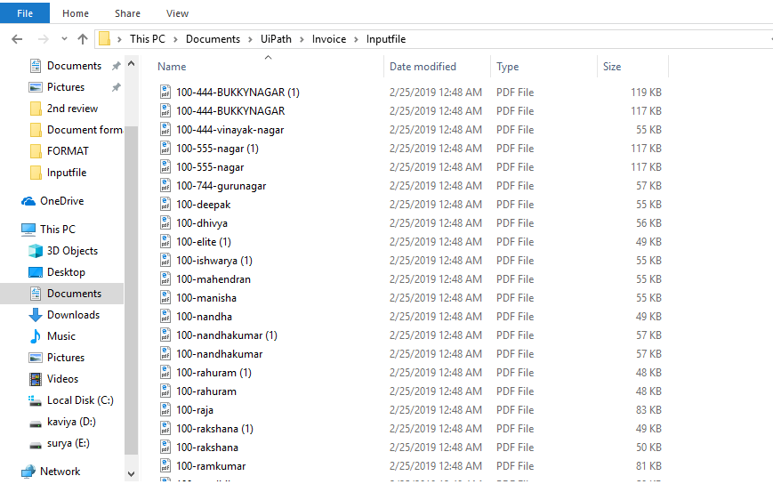

1. Folder

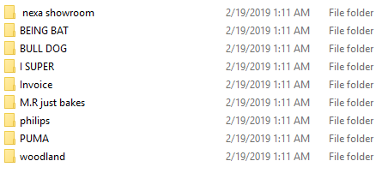

The output will be a business file mentioned in excel spreadsheet with these columns:

* Invoice number
* Company name
* Company address
* Invoice date
* Due date
* Bill to